UJIAN TENGAH SEMESTER
PEMROGRAMAN WEB DASAR



Disusun oleh:
Rama Pramudya Wibisana 2022320019

PROGRAM STUDI SISTEM INFORMASI
FAKULTAS INFORMATIKA
UNIVERSITAS BINA INSANI
BEKASI
2023
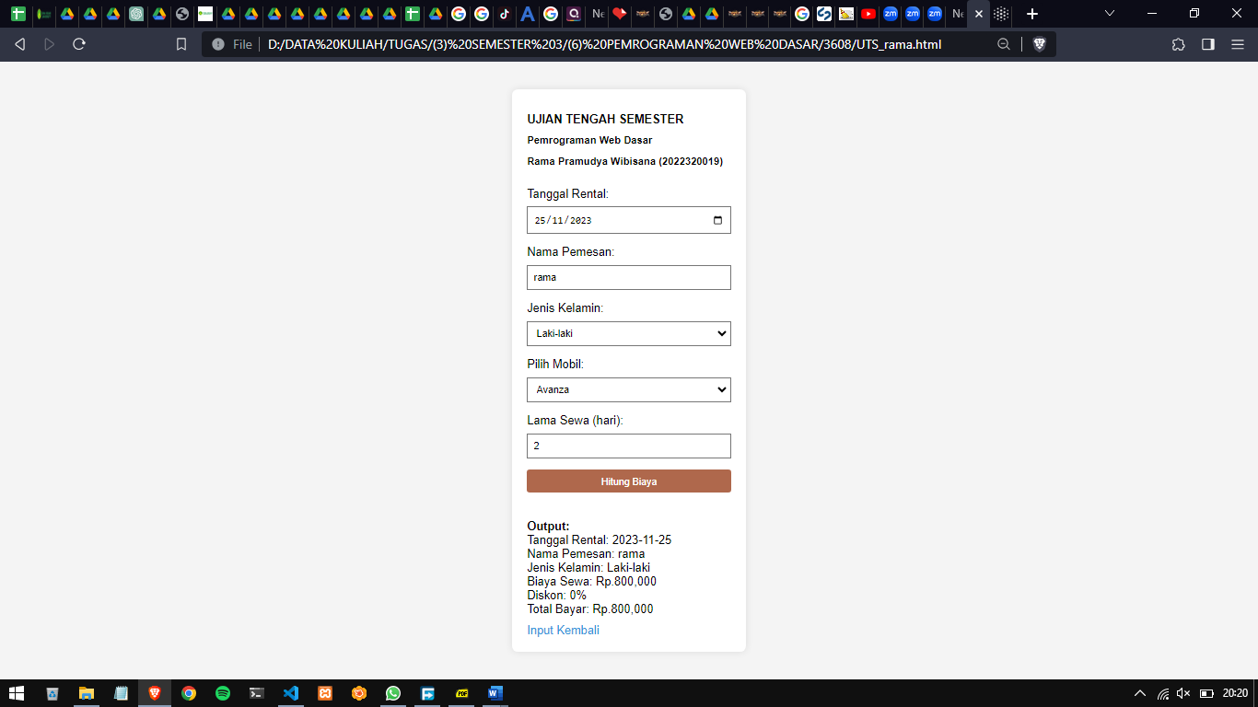

Source Code

<!DOCTYPE html>
<html lang="en">
<head>
<meta charset="UTF-8" />
<meta name="viewport" content="width=device-width, initial-scale=1.0" />
<link
rel="stylesheet"
href="https://fonts.googleapis.com/css2?family=Gotham:wght@300&display=swap"
/>
<style>
body {
font-family: "Gotham", sans-serif;
background-color: #f4f4f4;
margin: 0;
padding: 0;
display: flex;
align-items: center;
justify-content: center;
height: 100vh;
}
.form-container {
background-color: #fff;
padding: 20px;
border-radius: 8px;
box-shadow: 0 0 10px rgba(0, 0, 0, 0.1);
text-align: left;
}
h1,
h2,
h3 {
font-size: 24px;
margin-bottom: 10px;
}
label {
display: block;
margin-bottom: 8px;
}
select,
input,
button {
width: 100%;
padding: 8px;
margin-bottom: 16px;
box-sizing: border-box;
}
button {
background-color: #af684c;
color: #fff;
border: none;
border-radius: 4px;
cursor: pointer;
}
button:hover {
background-color: #af684c;
}
.output-container {
margin-top: 20px;
}
a {
text-decoration: none;
color: #3498db;
display: block;
margin-top: 10px;
}
</style>
<script>
function calculateRent() {
var rentalDateInput = document.getElementById("rentalDateInput");
var customerNameInput = document.getElementById("customerNameInput");
var genderSelect = document.getElementById("genderSelect");
var carSelect = document.getElementById("carSelect");
var daysInput = document.getElementById("daysInput");
var outputContainer = document.getElementById("outputContainer");
var carType = carSelect.value;
var dailyRate = 0;
switch (carType) {
case "Agya":
dailyRate = 300000;
break;
case "Avanza":
dailyRate = 400000;
break;
case "Innova":
dailyRate = 500000;
break;
}
var rentalDays = parseInt(daysInput.value);
var rentalCost = dailyRate * rentalDays;
var discount = 0;
if (rentalCost > 1000000) {
discount = 0.1;
} else if (rentalCost > 2500000) {
discount = 0.2;
}
var totalCost = rentalCost - rentalCost * discount;
outputContainer.innerHTML =
"<strong>Output:</strong><br>" +
"Tanggal Rental: " +
rentalDateInput.value +
"<br>" +
"Nama Pemesan: " +
customerNameInput.value +
"<br>" +
"Jenis Kelamin: " +
genderSelect.value +
"<br>" +
"Biaya Sewa: Rp." +
rentalCost.toLocaleString() +
"<br>" +
"Diskon: " +
discount * 100 +
"%<br>" +
"Total Bayar: Rp." +
totalCost.toLocaleString();
}
</script>
</head>
<body>
<div class="form-container">
<h1 style="font-size: 16px; margin-bottom: 12px">
UJIAN TENGAH SEMESTER
</h1>
<h2 style="font-size: 14px; margin-bottom: 10px">
Pemrograman Web Dasar
</h2>
<h3 style="font-size: 14px; margin-bottom: 8px">
Rama Pramudya Wibisana (2022320019)
</h3>
<br />
<label for="rentalDateInput">Tanggal Rental:</label>
<input type="date" id="rentalDateInput" />
<label for="customerNameInput">Nama Pemesan:</label>
<input
type="text"
id="customerNameInput"
placeholder="Masukkan nama pemesan"
/>
<label for="genderSelect">Jenis Kelamin:</label>
<select id="genderSelect">
<option value="Laki-laki">Laki-laki</option>
<option value="Perempuan">Perempuan</option>
</select>
<label for="carSelect">Pilih Mobil:</label>
<select id="carSelect">
<option value="Agya">Agya</option>
<option value="Avanza">Avanza</option>
<option value="Innova">Innova</option>
</select>
<label for="daysInput">Lama Sewa (hari):</label>
<input type="number" id="daysInput" placeholder="Masukkan jumlah hari" />
<button onclick="calculateRent()">Hitung Biaya</button>
<div id="outputContainer" class="output-container"></div>
<a href="#" onclick="location.reload()">Input Kembali</a>
</div>
</body>
</html>

